**CHAPTER 1**

**INTRODUCTION**

* + - * **BACKGROUND OF THE PROJECT**
      * **OBJECTIVE OF THE PROJECT**
      * **SCOPE OF THE PROJECT**

**BACKGROUND OF THE PROJECT**

The academic process of higher education must achieve something that improves the learning process. To make this happen, universities must monitor and evaluate the results of the teaching process by looking at student performance. We are going to design, create and deliver software that will help universities promote a more productive and effective way to assess students everywhere and that is the goal of our project. Performance monitoring includes assessments that play an important role in providing students, teachers, administrators, and policymakers with the information they need to make decisions. If we talk about the main part of our project, here is the concept of Course Outcome (CO) and Program Learning Outcomes (PLO), each CO is mapped to a PLO, and through each PLO students are expected to learn from the course 'problem analysis, design, Skill implementation, etc. 'will be known. The system allows input from IEB to determine PLO requirements. The project will evaluate to see if the COS mapped PLOs are met for each student to assess student proficiency. Faculties then input COs for each of their students so that the system can map the COs to the PLO accordingly. PLOs are carefully and specially selected to ensure that students achieve the most in a course so that students can monitor their progress in each sector and pinpoint the areas where self-improvement and self-development are needed. We are hopeful that our software will help institutional students’ progress, departmental performance and assist in the distribution and allocation of their improved resources.

**OBJECTIVE OF THE PROJECT**

Student progress monitoring is a practice that helps teachers continually evaluate the effectiveness of their learning and use student performance data to make more significant instructional decisions. If the rate at which a particular student is learning seems inadequate, the teacher can adjust the instruction. Our project seeks to create user-friendly software that will serve as a platform for many to improve the quality of education of students, faculty, and other members of the university and in advanced technology in the field of education. We believe that the information we have collected, evaluated, and equipped will lead to opportunities for greater advances in our education and will also make a significant contribution to computer science.

**SCOPE OF THE PROJECT**

This CHAPTER will discuss falls within the scope of the system. To recognize the importance or quality of the scope, we are to contemplate what the system will accomplish i.e. The purpose of the system and the desired requirements that are to be met.

The main purpose of implementing such a system is to improve and digitalize the old inefficient way. In the exciting system, there exists several human roles (e.g., faculty, students) that are to get the work done manually, not by computers. Therefore, the existing system takes more time to achieve the goals while compared to the newly proposed system. The new system accomplishes this by reducing the human roles of the system and making a computer which helps us to run the system and do the work of organizing, storing and instantly querying the essential data.

* Storing useful data
* Securing the data by restricting access to the system.
* Instantly insert/ update/ delete data from the database
* Generate dynamic charts from the data using defined or dynamic parameters.
* Reporting
* Project management

**CHAPTER 2**

**REQUIREMENT ANALYSIS**

* **RICH PICTURE AS-IS**
* **SIX ELEMENTS AS IS**
* **PROCESS DIAGRAM AS-IS**
* **PROBLEM ANALYSIS**
* **RICH PICTURE TO-BE**
* **SIX ELEMENTS TO-BE**
* **PROCESS DIAGRAM TO BE**

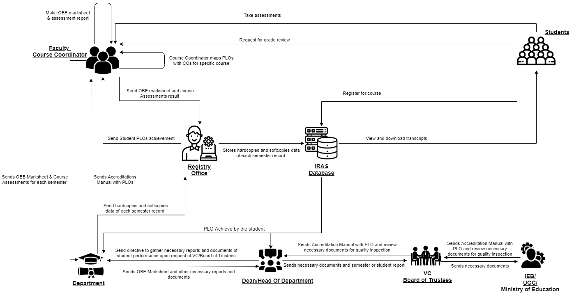RICH PICTURE (AS-IS)

**Figure 2.1: Rich Picture (As-Is)**

**SIX ELEMENTS (AS-IS)**

|  |  |  |  |  |  |  |
| --- | --- | --- | --- | --- | --- | --- |
| **Process** | **System Roles** | | | | | |
| **Human** | **Non-Comp**  **Hardware** | **Computing**  **Hardware** | **Software** | **Database** | **Network &**  **Communication** |
| Map Course  Outcomes (COs)  to Program  Learning  Outcomes (PLOs) | **IEB/UGC/ Ministry of**  **Education:**  1. Send Accreditation Manual  with PLOs defined to VC/ Board Of trusties.  **VC/ Board Of trusties**  1. Receive Accreditation Manual  from IEB.  2. Send the Accreditation manual  to Department Staff.  **Head of Department / Dean of**  **School:**  1. Send the Accreditation manual  to Department Staff.  2. Direct Department Staff to tell  Course Instructors and  Coordinators to design Course  Outline and Course Assessment  Reports.  **Department:**  1. Send Course Instructors the  Accreditation Manual with  defined PLOs.  **Course Instructor:**  1.Check if previous course content is present form register office, otherwise make new course content.  2. List COs.  3. Map Course Content to Course  Outcomes (COs).  4. Map COs to PLOs.  5. Map COs to specific questions  of Mid-term, Final Exams  questions and Project Work.  6. Starting to design course  assessment report using course  outline, Course Content and COs.  **Register Office:**  1.Send course content to course instructor if available otherwise send negative message. | **Pen and paper:**  1. Is used for noting  down intermediate  brainstorming ideas.  **Board and marker:**  1. Is used for noting  down intermediate  brainstorming ideas. | **Computer:**  1. Course  Coordinators use  computers to make  softcopies of Course  Outcomes (COs) of  the specific courses  they are experts in.  **Printer:**  1. To print out  hardcopies of Course  Outcomes (COs). | **MS Word:**  1. Course  Coordinators use  MS Word to make  a detailed course  outline and Course  Assessment  Reports with  Course Outcomes  (COs) mapping to  Program Learning  Outcomes (PLOs).  **Excel Sheet:**  1. Excel Sheet is  used by Course  Coordinators to  map specific  questions in the  Midterm, Final  exams and Project  work to specific  Course Outcomes  (COs). | **IRAS Database**  **server:**  1. IRAS uses a  database server to  store and maintain  student grades’ information. | 1. Use the internet and emails  to communicate with  UGC/IEB or other  stakeholders to discuss  important topics related to  mapping Course Outcomes to  Program Learning Outcomes.  **Others:**  1. Use phones or physical  means with stakeholders to  discuss important topics  related to mapping Course  Outcomes to Program  Learning Outcomes. |
| Check Number of student enrollment in a department | **Student:**  1. Student enroll in a specific Degree program.  2. Student information is sent to register’s office.    **Register Office:**  1.Gather all the new student’s information.  2. Assign the data in sheet of student information of designated departments.  3.Send the new update data to each department.  **Department:**  1.Recieve the data of new student.  2.Update it in the existing database  3. Send the data to department heads or deans for further inspection  **Department Head/Dean:**  1.Recieve the data from department.  2.Make calculation of number of new student enrollment comparing to previous cases.  3. Make calculation number of categorize students, such as merit base, physical aid and others | **Pen and Paper**  1. Sheet of number of students in a department is made along with student’s information. | **Computer/ Phone:**  1. Uses computers to  make softcopies of  report or sheet of student information in departments.  **Printer:**  1. Print hardcopies of report and sheet | **Coded Excel**  **sheet:**  1.Deparment head or dean uses  automated excel  sheets to calculate  the number student’s  in the department.  **MS Word:**  1. Used to make  report  softcopies. | **Department**  **Storage:**  1. Records of  students’ enrollment in the department.    **Registrar’s Office**  **Storage:**  1. Records of  students’ enrollment for all the departments. | **Internet/Mail:**  **1.** An Online platform (such as  Google Sheets) may be used  for processing the student information data spreadsheet. |
| Register for course | **Student:**  1. Login to IRAS  2. Student enroll in specific courses if all the pre requisite courses are completed otherwise can’t process end.  3. Request for bill  4. Receive for bill  5. Pay the bill    **Register Office:**  1.Store request asked by the student and send the billing date  2. Receive billing data  3. If bill paid stored data is updated to database otherwise process end and student had to drop the course.  4. Send student information to Department.  **Department:**  1.Recieve the data of enroll student.  2. Send the data of enroll student to course instructor.  **Instructor**  1. Receive data of enrolled student.  2. Allocate space for the new student data in OEB marksheet. | **Pen and Paper**  1. Sheet of number of students enrolled for the course. | **Computer/ Phone:**  1. Uses computers to  make softcopies of  report or sheet of student information enrolled for the course.  **Printer:**  1. Print hardcopies of report and sheet | **Coded Excel**  **sheet:**  1.Instructor uses  automated excel  sheets for the semester OEB marksheet.  **MS Word:**  1. Used to make  report  softcopies. | **Department**  **Storage:**  1. Records of  students’ enrollment in the course.    **Registrar’s Office**  **Storage:**  1. Records of  students’ enrollment in the course. | **Internet/Mail:**  **1.** An Online platform (such as  Google Sheets) may be used  for processing the student information data spreadsheet. |
| Record Student  Assessment Data | **Faculty/ Course Coordinator:**  1. Assign project work and  assignments according to course outline.  2. Take quizzes and exams  throughout the semester according to course outline.  3. Record assessment data of  students throughout the semester  of each student for every  assessment (quizzes, assignments,  project, exams) on softcopies and  hardcopies.  4. Record marks for each specific  question in the midterms and final  exams.  5. Calculate total marks of  quizzes, assignments and midterm  and final exams and assign final  grades to each student of specific  courses.  6. Convert finals and midterms  marks.  7. Bring all the marks of every  student for a course into a  Marksheet.  8. Grade the student according to current mark distribution if no change is needed else adjustment has been made.  9. Upload students’ final grades on  IRAS.  10. Send the Marksheet to the  Department.  11. Send the Marksheet to admin to store in the database | **Pen & Paper:**  1. Use pen & paper to  record assessment  data and marks  obtained on physical  paper in tabular  format(hardcopies). | **Computer:**  1. Creating  softcopies of records  of all assessment data  for specific courses  are done on  computers. | **Excel Sheet:**  1. Record  necessary  assessment data  and final grades on  Excel Sheets.  **IRAS:**  1. Upload students'  final grades to  IRAS for viewing  by students or the  registrar’s office. | **Department**  **Storage:**  1. Records of  students’  assessment data  and final grades  may be saved in  the department  office and  registrar’s office  for future  reference.  **IRAS Database**  **server:**  1. IRAS uses a  database server to  store and maintain  student grades’ information. | **Internet:**  1. The Internet is used to  communicate with IRAS to  store final grades of students. |
| Produce OBE  Marksheet &  Course  Assessment  Report | **Faculty:**  1. Calculate total marks received for  each CO by calculating the marks  received for questions and/or other  assessments mapped to COs.  2. Calculate total percentages received  for each COs on the OBE Marksheet.  3. Declare if a student has achieved a  specific CO (if CO percentage is  greater than or equal to 40).  4. Declare if a student has received a  PLO for a related CO.  5. Make a table giving the verdict and  analysis of how many students were  able to receive a certain CO and PLO  and other documents containing  necessary information and data.  6. Design Course Assessment Report  using Course Outline, Course Content  and Course Outcomes.  7. Send the final version of the OBE  Marksheet to the Dept. Office.  **Department Office:**  1. Send the OBE marksheet, Course  Assessment Report and others to the  Registrar’s Office.  2. Store the OBE Marksheet and  Course Assessment Report in the  department.  **Registry Office:**  1. Stores the OBE Marksheet and  Course Assessment Reports and other  documents and reports in the  Registrar's Office. | **Pen and Paper**  1. OBE marksheet  stored in hardcopy.  Additional markings  may be made to  further separate  between students. | **Computer/ Phone:**  1. Uses computers to  make softcopies of  the OBE Marksheet  and Course  Assessment Reports.  **Printer:**  1. Print hardcopies of  final versions of the  OBE Marksheets and  Course Assessment  Reports. | **Coded Excel**  **sheet:**  1.Faculty/Course  Coordinator uses  automated excel  sheets to calculate  the student’s  success/ failure in  achieving PLOs.  **MS Word:**  1. Used to make  Course  Assessment Report  softcopies. | **Department**  **Storage:**  1. Records of  students’  assessment data  and final grades  will be saved in  the department for  future reference.  **Registrar’s Office**  **Storage:**  1. OBE  Marksheets,  Course  Assessment  Reports and other  documents  submitted by the  department is  stored for future  reference. | **Internet/Mail:**  **1.** An Online platform (such as  Google Sheets) may be used  for processing the OBE  assessment data spreadsheet. |
| View grades and  download  Transcripts | **Students**:  1. Log into IRAS.  2. Search semester wise result  for intended semester.  3. See grades for specific  semesters.  4. Download transcript through  browser into hard disk.  **Dean/DOH:**  1. Log into IRAS.  2. Search semester wise result  for intended semester for a specific student.  3. See grades for specific  semesters.  4. Download transcript through  browser into hard disk.  **Faculty/Higher Officials:**  1. Request register office for transcript of particular student or semester of a particular course.  2. Receive transcript of particular student or semester of a particular course.  **Registry Office:**  1. Access IRAS.  2. View students’ grades if and  when it’s necessary.  3. Download their transcripts.  4. Send transcript | **Pen and Paper**  1. Tabulated  transcripts may be  printed onto paper.  Hardcopy is used as  the primary source of  truth during  applications and other  paperwork. | **Computer/**  **Phone:**  1. Used for accessing  IRAS.  **Printer:**  1. Used to print the  tabulated transcript.  Prints tabulated  transcripts. | **IRAS:**  1. **Store’s** letter  grades of each  completed course  2. Provides the  online user  **interface** for  viewing grades  and transcripts. | **Registrar’s Office**  **Storage:**  1. Student  information is kept  in admin in  hardcopies for  future reference.  **IRAS Database**  **Server:**  1. A Database  Management  Service is used to  store, maintain,  edit and receive  student grades  information in  IRAS.  **Web Server:**  1. User interface  and website pages  are served using a  remote web server. | **Internet/ Email**  1. The **Internet** is used to  communicate with IRAS to  store final grades of students.  2. Softcopies may be **mailed**. |
| View Records  OBE Marksheets,  Course  Assessment  Reports over a  time period for  inspection and  analysis of student  performance trend | **IEB/ UGC:**  1. Inform the VC of a deadline  within which OBE Marksheets, Course  Assessment Reports and other documents  are needed for quality inspection to make  necessary improvements to degree  programs.  2. Inform the university head if govt.  official will visit the campus.  3. Visit university and relevant depts to  receive the necessary documents and  reports.  **Head of Dept/Dean of School:**  1. Request to view records of OBE  Marksheets, Assessment Reports to  analyze students’ performance trends.  2. Direct Department Staff to gather  necessary documents, OBE Marksheets,  Assessment report for a given time-period  specified by govt. officials.  3. Receive the necessary documents  gathered by the dept.  4. Evaluate the need to change/ improve  the department’s educational resources  based on students’ performance trends.  **VC/Board of Trustees:**  1. Request to view records of OBE  Marksheets, Assessment Reports to  analyze students’ performance trends.  **Departmental:**  1. Gather necessary OBE Marksheets,  Assessment Reports & other documents.  2. Provide all the necessary documents to  govt. officials.  **Faculty/Higher Officials:**  1. Request register office for OBE marksheet semester of a particular course.  2. Receive OBE marksheet semester of a particular course.  **Registry Office:**  1. Access IRAS.  2. Gather OBE marksheet from database.  3. Send OBE marksheet. | **Pen and Paper:**  1. May be used for  noting/marking down  key points of the  report.  2. Hardcopies of  reports may be used. | **Computer:**  1. Used to display  OBE Marksheet and  Course Assessment  Report softcopies.  2. Send OBE and  Course Assessment  Reports to other  computers. |  | **Department**  **Records**  1. Retrieval of  OBE marksheets  and Course  Assessment  reports when  needed.  2. Stores records  on stakeholders’  interpretation of  student  performance  trends. | **The internet:**  1. OBE marksheets and course  assessment reports may be  **mailed** online.  2. Online platforms such as  Google Docs/Sheets display  reports of softcopies. |
| Request for  review and change  of grades | **Students:**  1. Request for grade change and  review to faculty.  **Faculty/ Course Coordinator:**  1. Check exam papers and other  assessments upon request.  2. If change needs to be made,  send a grade change request of a  specific student to register office.  If not, end the process.  **Register Office:**  1. Receive a request to change the  grade of a specific student.  2. Change grade of student based  on Faculty request. | **Pen and Paper:**  1. May be used to  note down key points  or marks on the  students’ answer  sheets. | **Computer/ Phone:**  1. Used for  communicating with  the faculty. | **IRAS**:  1. Used by the  admin for  changing the  grade. | **IRAS server:**  1. Update student  grade data.  **Department**  **Storage:**  1. Update student  grade data.  **Registrar’s Office**  **Storage:**  1. Update student  grade data. | **Internet:**  1. Email is primarily used for  communication.  **Phone:**  1. May be used for  communication. |

**PROCESS DIAGRAM (AS-IS)**

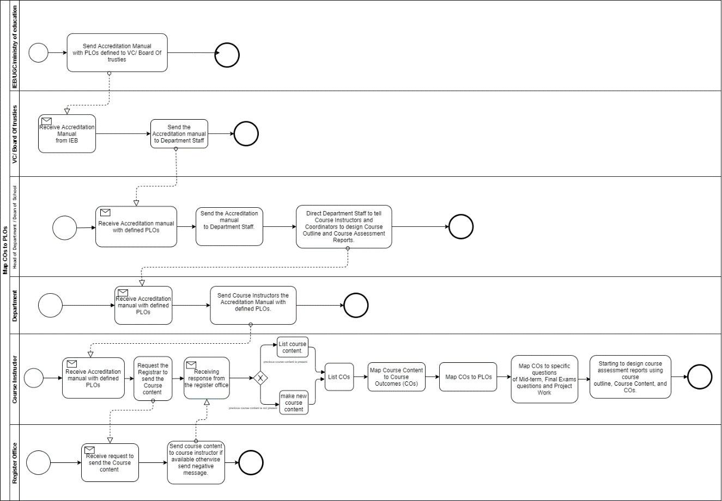

**Figure 2.3: Process Diagram for Map COs to PLOs**

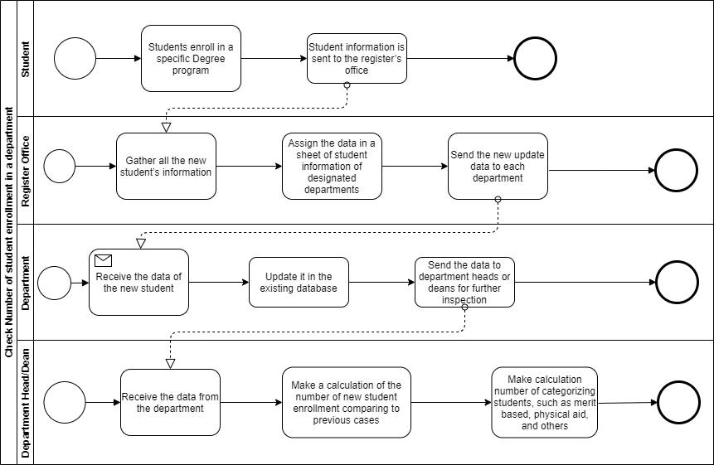

**Figure 2.4: Process Diagram for Check Number of student enrollment in a department**

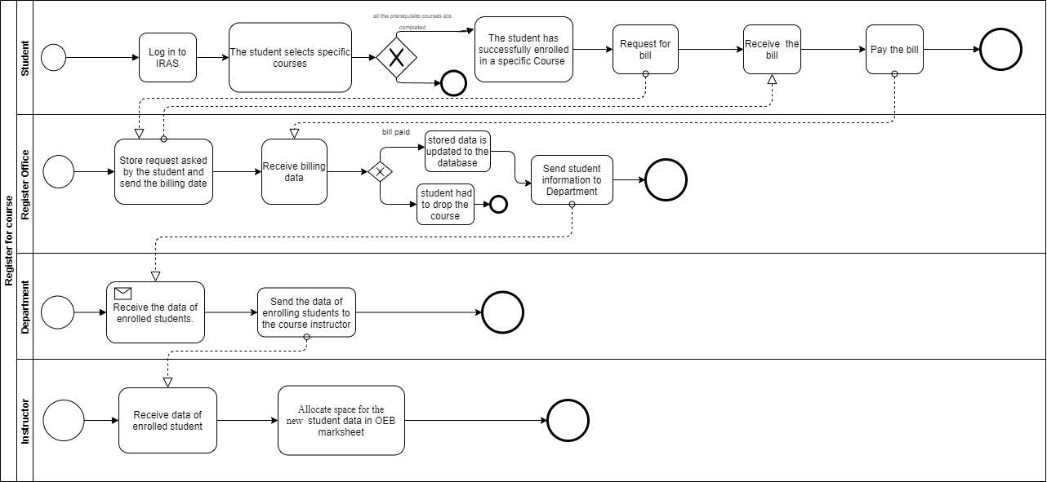

**Figure 2.5: Process Diagram for Register for course**

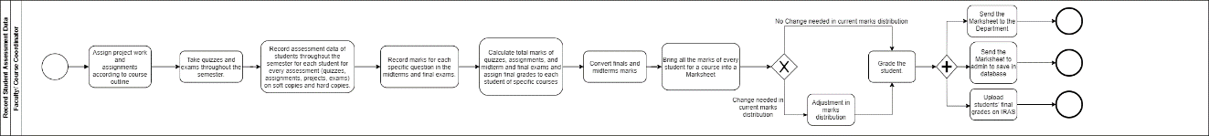

**Figure 2.6: Process Diagram for Record Student Assessment Data**

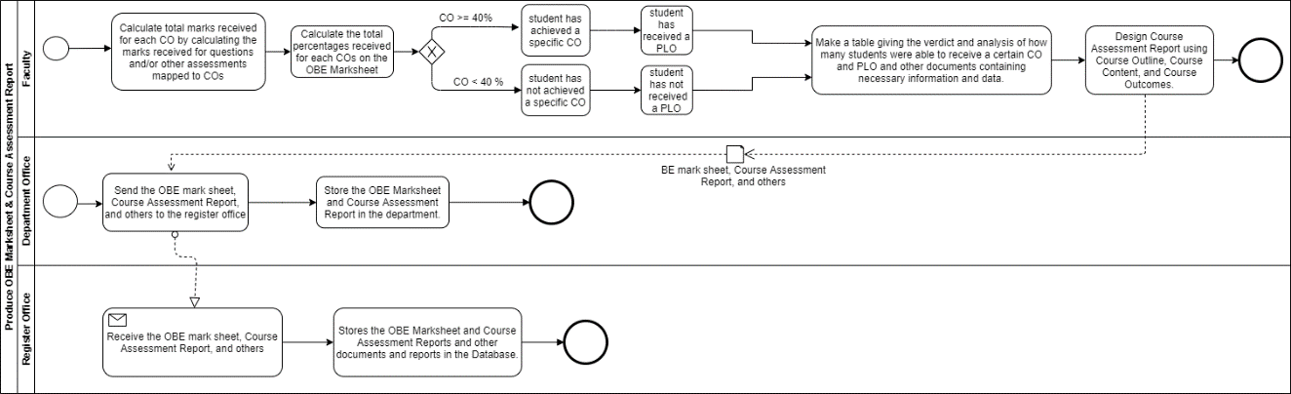

**Figure 2.7: Process Diagram for Produce OBE Marksheet & Course Assessment Report**

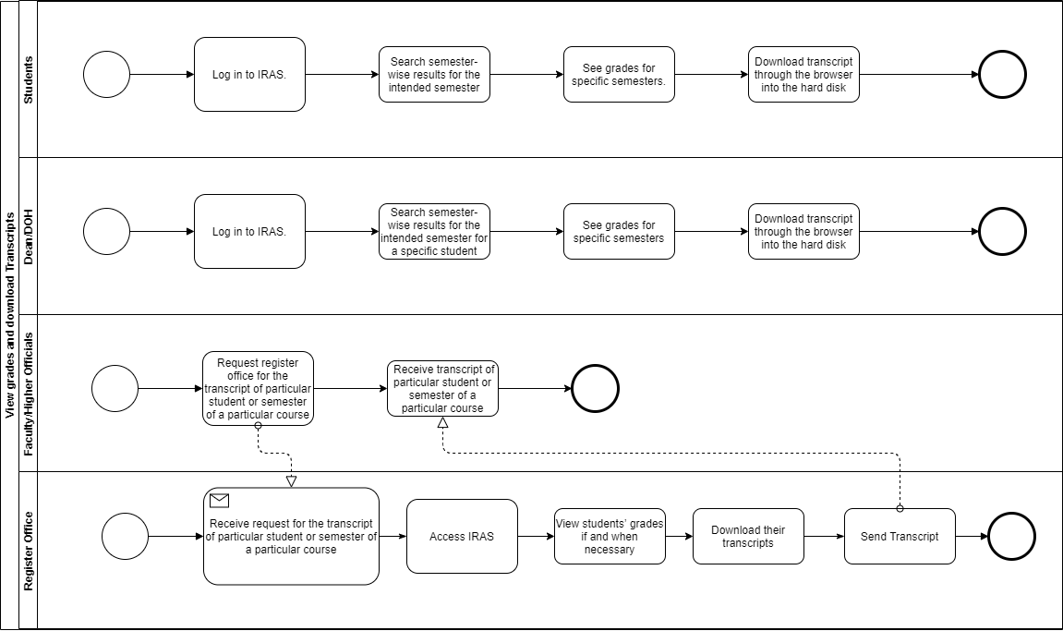

**Figure 2.8: Process Diagram for View grades and download Transcripts**

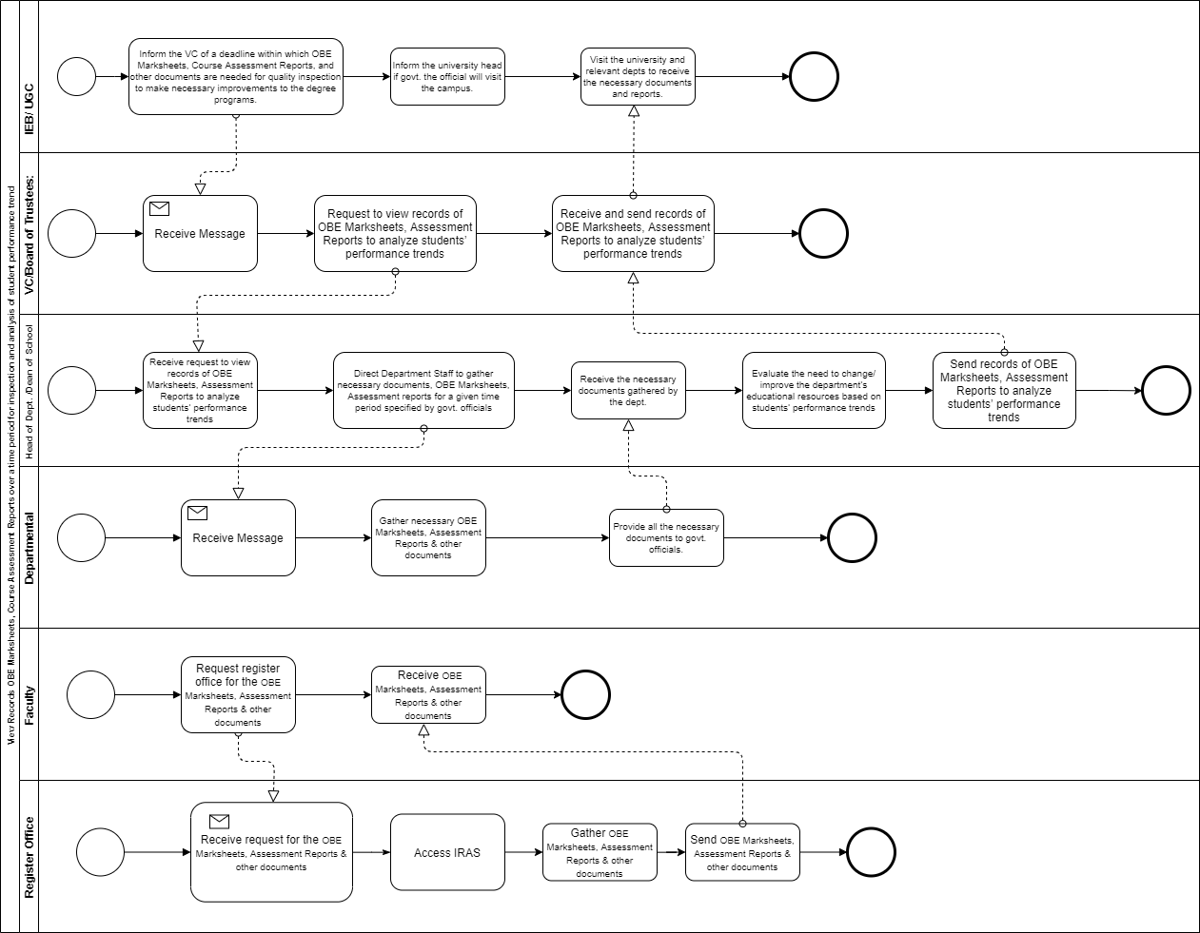

**Figure 2.9: Process Diagram for View Records OBE Marksheets, Course Assessment Reports over a time period for inspection and analysis of student performance trend**

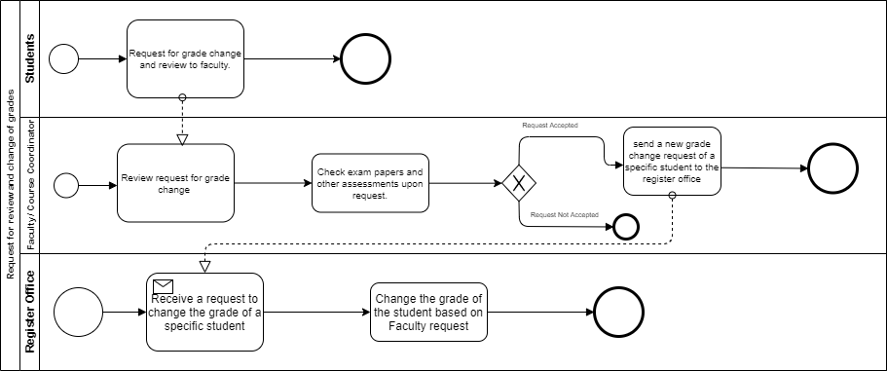

**Figure 2.10: Process Diagram for Request for review and change of grades**

**PROBLEM ANALYSIS**

|  |  |  |  |  |
| --- | --- | --- | --- | --- |
| Process Name | Stakeholders | Concerns (Problems) | Analysis (reason of the problem) | Proposed solution |
| Map course outcomes (COs) to program Learning Outcomes (PLOs) | 1.Faculties | 1.VC has to collect and send CO and PLO data to the Dean.  2.Dean sends data to department head and then it is passed to department.  3.Course instructor implements CO and PLO in their course. | The process is very complicated and time consuming as faculties must wait for other non-essential stakeholders to implement PLO and CO in their courses. | We can eliminate the involvement of department by giving faculties direct access to update PLOs and COs in our software and department head to update the PLO after further inspection |
| Check number of student enrollment in a department | 1.Department  2.Dean | 1.Register office collects all the new student’s information.  2.Register office sends updated data to each department. 3.Department updates data to database. Then sends new data to Dean.  4. Dean makes calculation to see student enrollment comparison. | Same information is being send to different stakeholders individually. Which creates unnecessary repetition. Which makes the overall process time consuming. | We can make this information centralized, so that all the stakeholders can see latest information any time. We can also generate custom comparison Graphs/charts for any individual stakeholder. |
| Record Student  Assessment Data to SPM | 1.Faculty | 1. Faculty had to calculate the total assessments marks and convert finals and midterms  Marks of each student.  2. Bring all the marks of every  student for a course into a  Marksheet.  3. Grade the student | Making all the calculation manually is too much time consuming and chances human error is greater. | All the calculation can be done in SPM and graded accordingly. Adjustment in marks distribution can easily be made if change is needed |
| Produce OBE  Marksheet &  Course  Assessment  Report | 1.Faculty | 1. All calculation have to done manually  2. Need to send data to register office to update database | Making all the calculation manually and waiting for register office to update data is too much time consuming and chances human error is greater. | Calculation can be done by the help of the software and OEB marksheet can directly uploaded to database using the software |
| View records, OBE marksheets and Course assessment report | 1.IEB/UGC  2.Dean  3.VC  4.Faculty | 1. Faculty can’t access the OEB marksheet directly  2. Calculations have to done manually and charts have to make manually to make comparison | Too many manual processes which takes time and resource. Therefore, lowers overall efficiency | We will generate automated charts, graphs and report for relevant stakeholder. we can collect most of the relevant data directly from IRAS, which will eliminate any extra steps.  Faculty can view OEB marksheet of past semesters. |
| Request for review and change grade | 1.Faculty | 1. Faculty need to send request to register office to change the grade | Grade change could be done by faculty. Sending request to register office for grade upgrade adds extra work. | By giving access to change grade in our system we could eliminate the involvement of register office in our system. |

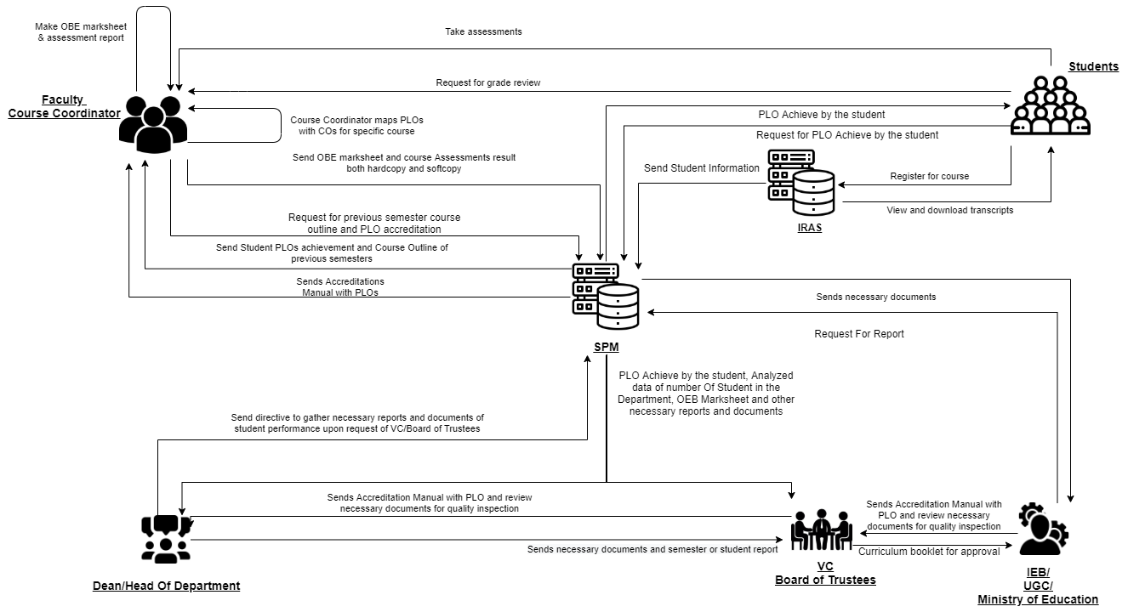**RICH PICTURE (TO-BE)**

**Figure 2.11: Rich Picture (To-Be)**

SIX ELEMENTS (TO-BE)

|  |  |  |  |  |  |  |
| --- | --- | --- | --- | --- | --- | --- |
| **Process** | **System Roles** | | | | | |
| **Human** | **Non-Comp**  **Hardware** | **Computing**  **Hardware** | **Software** | **Database** | **Network &**  **Communication** |
| Map Course  Outcomes (COs)  to Program  Learning  Outcomes (PLOs) | **IEB/UGC/ Ministry of**  **Education:**  1. Send Accreditation Manual  with PLOs defined to VC/ Board Of trusties.  **VC/ Board Of trusties**  1. Receive Accreditation Manual  from IEB.  2. Send the Accreditation manual  to Department Staff.  **Head of Department / Dean of**  **School:**  1. Receive Accreditation Manual  from IEB.  2. Send the Accreditation manual  to SPM  3. Direct Department Staff to tell  Course Instructors and  Coordinators to design Course  Outline and Course Assessment  Reports.  **Course Instructor:**  1.Check if previous course content is present from SPM, otherwise make new course content.  2. List COs.  3. Map Course Content to Course  Outcomes (COs).  4. Map COs to PLOs.  5. Map COs to specific questions  of Mid-term, Final Exams  questions and Project Work.  6. Starting to design course  assessment report using course  outline, Course Content and COs. | **Pen and paper:**  1. Is used for noting  down intermediate  brainstorming ideas.  **Board and marker:**  1. Is used for noting  down intermediate  brainstorming ideas. | **Computer:**  1. Course  Coordinators use  computers to make  softcopies of Course  Outcomes (COs) of  the specific courses  they are experts in.  **Printer:**  1. To print out  hardcopies of Course  Outcomes (COs). | **MS Word:**  1. Course  Coordinators use  MS Word to make  a detailed course  outline and Course  Assessment  Reports with  Course Outcomes  (COs) mapping to  Program Learning  Outcomes (PLOs).  **Excel Sheet:**  1. Excel Sheet is  used by Course  Coordinators to  map specific  questions in the  Midterm, Final  exams and Project  work to specific  Course Outcomes  (COs). | **IRAS Database**  **server:**  1. IRAS uses a  database server to  store and maintain  student grades’ information.  **SPM**  **database:**  1. Records of  PLOs | 1. Use the internet and emails  to communicate with  UGC/IEB or other  stakeholders to discuss  important topics related to  mapping Course Outcomes to  Program Learning Outcomes.  **Others:**  1. Use phones or physical  means with stakeholders to  discuss important topics  related to mapping Course  Outcomes to Program  Learning Outcomes. |
| Check Number of student enrollment in a department from SPM | **Student:**  1. Student enroll in a specific Degree program.  2. Student information is sent to SPM from IRAS.  **Department Head/Dean:**  1.Recieve the data from SPM  2. School-wise, department-wise and program-wise student enrollment comparison can be seen.  **VC/Board of Trustees:**  1.Recieve the data from SPM  2. School-wise, department-wise and program-wise student enrollment comparison can be seen. | **Pen and Paper**  1. Sheet of number of students in a department is made along with student’s information. | **Computer/ Phone:**  1. Uses computers to  make softcopies of  report or sheet of student information in departments.  **Printer:**  1. Print hardcopies of report and sheet | **Coded Excel**  **sheet:**  1.Deparment head or dean uses  automated excel  sheets to calculate  the number student’s  in the department.  **MS Word:**  1. Used to make  report  softcopies. | **IRAS database**  1. Records of  students’ enrollment in the department.  **SPM**  **database:**  1. Records of  students’ enrollment for all the departments. | **Internet/Mail:**  **1.** An Online platform (such as  Google Sheets) may be used  for processing the student information data spreadsheet.  **2.** Internet to access to SPM |
| Register for course | **Student:**  1. Login to IRAS  2. Student enroll in a specific course if all the pre requisite courses are completed otherwise can’t process end.  3. Request for bill  4. Receive for bill  5. Pay the bill    **Instructor**  1. Receive data of enrolled student.  2. Add student data in OEB marksheet. | **Pen and Paper**  1. Sheet of number of students enrolled for the course. | **Computer/ Phone:**  1. Uses computers to  make softcopies of  report or sheet of student information enrolled for the course.  **Printer:**  1. Print hardcopies of report and sheet | **Coded Excel**  **sheet:**  1.Instructor uses  automated excel  sheets for the semester OEB marksheet.  **MS Word:**  1. Used to make  report  softcopies. | **Department**  **Storage:**  1. Records of  students’ enrollment in the course.    **IRAS database:**  1. Records of  students’ enrollment in the course. | **Internet/Mail:**  **1.** An Online platform (such as  Google Sheets) may be used  for processing the student information data spreadsheet. |
| Record Student  Assessment Data to SPM | **Faculty/ Course Coordinator:**  1. Assign project work and  assignments according to course outline.  2. Take quizzes and exams  throughout the semester according to course outline.  3. Record assessment data of  students throughout the semester  of each student for every  assessment (quizzes, assignments,  project, exams) on softcopies and  hardcopies.  4. Record marks for each specific  question in the midterms and final  exams.  5. SPM calculate total marks of  quizzes, assignments and midterm  and final exams and assign final  grades to each student of specific  courses.  6. Convert finals and midterms  marks.  7. Bring all the marks of every  student for a course into a  Marksheet.  8. Grade the student according to current mark distribution if no change is needed else adjustment has been made.  9. Submit students’ final grades and marksheet on  SPM. | **Pen & Paper:**  1. Use pen & paper to  record assessment  data and marks  obtained on physical  paper in tabular  format(hardcopies). | **Computer:**  1. Creating  softcopies of records  of all assessment data  for specific courses  are done on  computers. | **Excel Sheet:**  1. Record  necessary  assessment data  and final grades on  Excel Sheets.  **IRAS:**  1. Upload students'  final grades to  IRAS for viewing  by students or the  registrar’s office.  **SPM**  1. Upload student from IRAS to SPM | **SPM:**  1. Records of  students’  assessment data  and final grades  may be saved in  the SPM  for future  reference.  **IRAS Database**  **server:**  1. IRAS uses a  database server to  store and maintain  student grades’ information. | **Internet:**  1. The Internet is used to  communicate with IRAS to  store final grades of students.  2.Internet to access SPM |
| Produce OBE  Marksheet &  Course  Assessment  Report to SPM | **Faculty:**  1. Upload Marks in SPM to calculate total marks received for  each CO by calculating the marks  received for questions and/or other  assessments mapped to COs.  2. SPM calculate total percentages received  for each COs on the OBE Marksheet.  3. Declare if a student has achieved a  specific CO (if CO percentage is  greater than or equal to 40).  4. Declare if a student has received a  PLO for a related CO.  5. SPM make a table giving the verdict and  analysis of how many students were  able to receive a certain CO and PLO  and other documents containing  necessary information and data.  6. Design Course Assessment Report  using Course Outline, Course Content  and Course Outcomes.  7. Submit the final version of the OBE  Marksheet to the SPM | **Pen and Paper**  1. OBE marksheet  stored in hardcopy.  Additional markings  may be made to  further separate  between students. | **Computer/ Phone:**  1. Uses computers to  make softcopies of  the OBE Marksheet  and Course  Assessment Reports from SPM.  **Printer:**  1. Print hardcopies of  final versions of the  OBE Marksheets and  Course Assessment  Reports from SPM | **Coded Excel**  **sheet:**  1.Faculty/Course  Coordinator uses  automated excel  sheets to calculate  the student’s  success/ failure in  achieving PLOs from SPM  **MS Word:**  1. Used to make  Course  Assessment Report  softcopies.  **SPM**  1. Store CLO and PLO information to SPM | **SPM**  **Storage:**  1. Records of  students’  assessment data  and final grades  will be saved in  the department for  future reference in the SPM | **Internet/Mail:**  **1.** An Online platform (such as  Google Sheets) may be used  for processing the OBE  assessment data spreadsheet.  2. Internet to Access SPM |
| View grades and  download  Transcripts | **Students**:  1. Log into SPM.  2. Search semester wise result  for intended semester.  3. See grades for specific  semesters.  4. Download transcript through  browser into hard disk.  **Dean/DOH:**  1. Log into SPM.  2. Search semester wise result  for intended semester for a specific student.  3. See grades for specific  semesters.  4. Download transcript through  browser into hard disk.  **Faculty/Higher Officials:**  1. Log into SPM.  2. Search semester wise result  for intended semester for a specific student.  3. See grades for specific  semesters.  4. Download transcript through  browser into hard disk. | **Pen and Paper**  1. Tabulated  transcripts may be  printed onto paper.  Hardcopy is used as  the primary source of  truth during  applications and other  paperwork. | **Computer/**  **Phone:**  1. Used for accessing  IRAS.  **Printer:**  1. Used to print the  tabulated transcript.  Prints tabulated  transcripts. | **IRAS:**  1. **Store’s** letter  grades of each  completed course  2. Provides the  online user  **interface** for  viewing grades  and transcripts.  **SPM**  1. Store transcript data | **IRAS Database**  **Server:**  1. A Database  Management  Service is used to  store, maintain,  edit and receive  student grades  information in  IRAS.  **Web Server:**  1. User interface  and website pages  are served using a  remote web server.  **SPM**  **Storage:**  1. Records of  students’  assessment data  and final grades  will be saved in  the department for  future reference in the SPM | **Internet/ Email**  1. The **Internet** is used to  communicate with IRAS to  store final grades of students.  2. Softcopies may be **mailed**. |
| View Records  OBE Marksheets,  Course  Assessment  Reports over a  time period for  inspection and  analysis of student  performance trend from SPM | **IEB/ UGC:**  1. Login to SPM  2. View records of OBE marksheet course Assessment report over time period for inspection and analysis of student performance trend  3. Download OBE marksheet course assessment report  **Head of Dept/Dean of School:**  1. Login to SPM  2. View records of OBE marksheet course Assessment report over time period for inspection and analysis of student performance trend  3. Download OBE marksheet course assessment report  performance trends  .  **VC/Board of Trustees:**  1. Login to SPM  2. View records of OBE marksheet course Assessment report over time period for inspection and analysis of student performance trend  3. Download OBE marksheet course assessment report  **Faculty/Higher Officials:**  1. Login to SPM  2. View records of OBE marksheet course Assessment report over time period for inspection and analysis of student performance trend  3. Download OBE marksheet course assessment report | **Pen and Paper:**  1. May be used for  noting/marking down  key points of the  report.  2. Hardcopies of  reports may be used. | **Computer:**  1. Used to display  OBE Marksheet and  Course Assessment  Reports softcopies from SPM.  2. Send OBE and  Course Assessment  Reports to SPM.  3. View OBE Marksheet from SPM | **SPM**  1.Store information of OBE into SPM | **Department**  **Records**  1. Retrieval of  OBE marksheets  and Course  Assessment  reports when  needed from SPM  2. Stores records  on stakeholders’  interpretation of  student  performance  trends from SPM | **The internet:**  1. OBE marksheets and course  assessment reports may be  **mailed** online.  2. Online platforms such as  Google Docs/Sheets display  reports of softcopies.  3. Internet to access SPM |
| Request for  review and change  of grades | **Students:**  1. Request for grade change and  review to faculty.  **Faculty/ Course Coordinator:**  1. Check exam papers and other  assessments upon request.  2. If change needs to be made,  grade is changed in SPM and re-submitted.  If not, end the process. | **Pen and Paper:**  1. May be used to  note down key points  or marks on the  students’ answer  sheets. | **Computer/ Phone:**  1. Used for  communicating with  the faculty. | **SPM**:  1. Used by the  admin for  changing the  grade. | **SPM server:**  1. Update student  grade data. | **Internet:**  1. Email is primarily used for  communication.  **Phone:**  1. May be used for  communication. |

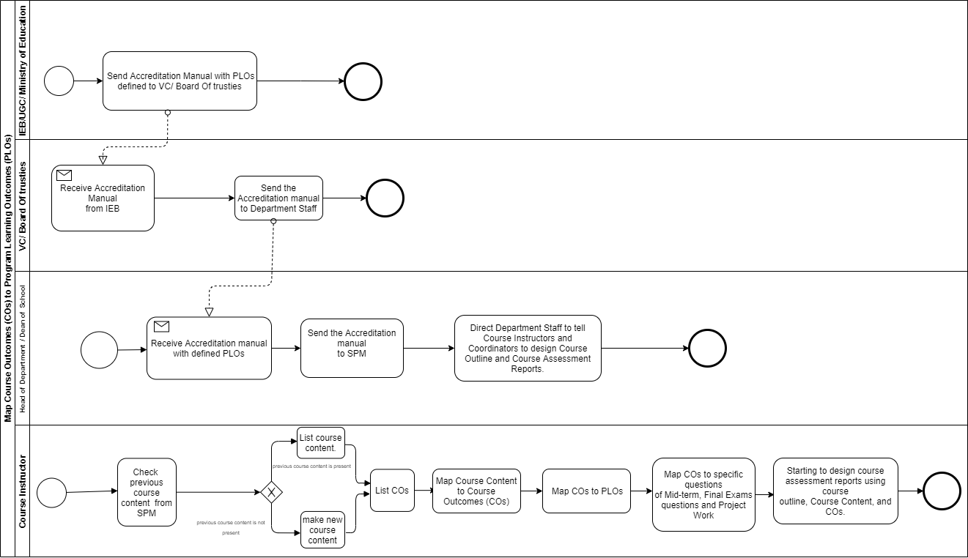**PROCESS DIAGRAM (TO-BE)**

**Figure 2.12: Process diagram for Map Course Outcomes (COs) to Program Learning Outcomes (PLOs)**

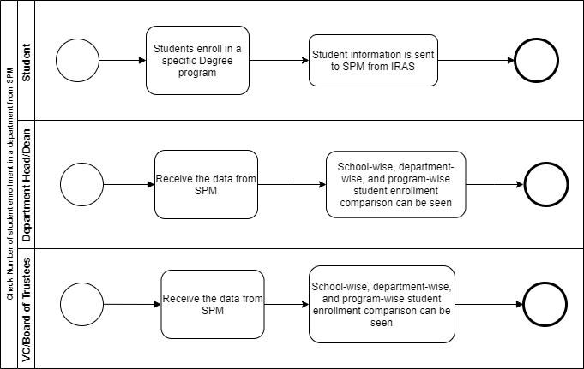

**Figure 2.13: Process diagram for Check Number of student enrollment in a department from SPM**

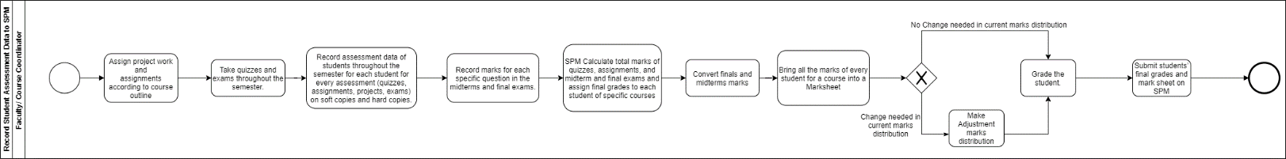

**Figure 2.14: Process diagram for Record Student Assessment Data to SPM**

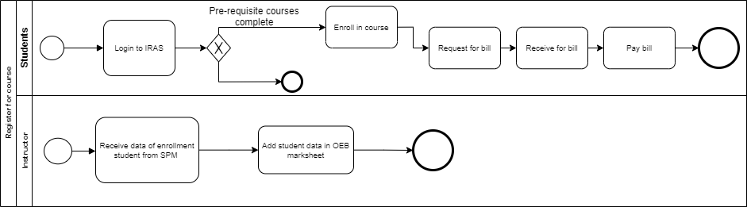

**Figure 2.15: Process diagram for Register for course**

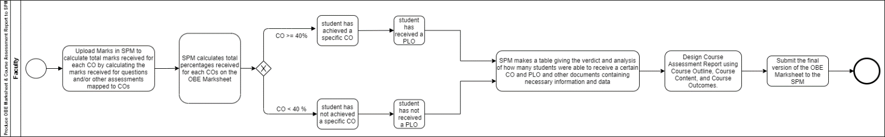

**Figure 2.16: Process diagram for Produce OBE Marksheet & Course Assessment Report to SPM**

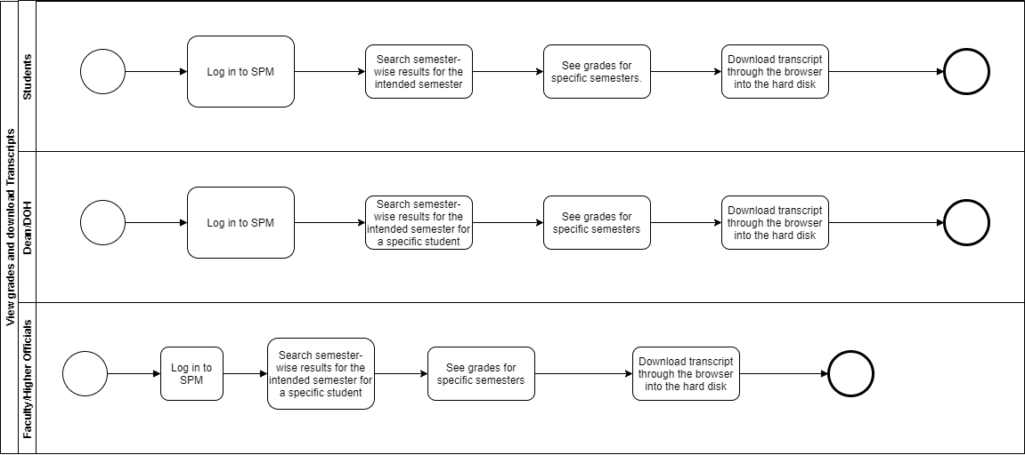

**Figure 2.17: Process diagram for View grades and download Transcripts**

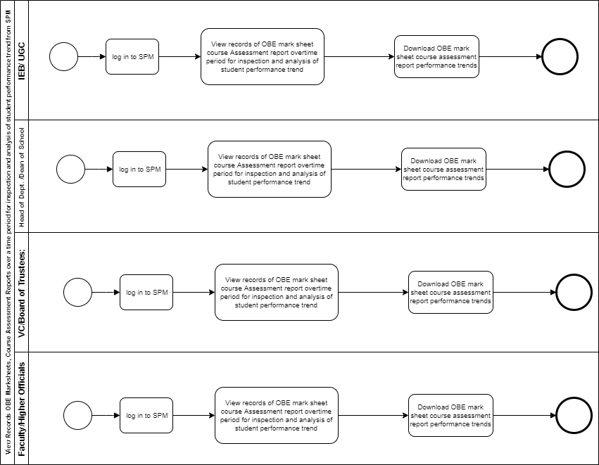

**Figure 2.19: Process diagram for View Records OBE Marksheets, Course Assessment Reports over a time period for inspection and analysis of student performance trend from SPM**

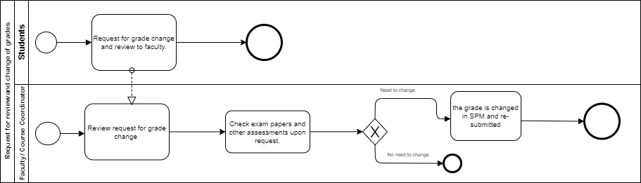

**Figure 2.20: Process diagram for Request for review and change of grades**

**CHAPTER 3**

**LOGICAL SYSTEM DESIGN**

* BUSINESS RULE
* ENTITY RELATIONSHIP DIAGRAM
* ENTITY RELATIONSHIP DIAGRAM TO RELATIONAL SCHEMA
* NORMALIZATION
* DATA DICTIONARY

**BUSINESS RULE**

All PLO (Program Learning Outcome) of each department and CO (Course Outcome) information of every course is recorded in the SPM system, which can be access by course instructor, department head, deans, VC, board of trustees and higher officials. In the case of a particular semester, the course instructor will be able to see how many students have been enrolled in each course. Department head, deans and VC can check how many students had enroll in a particular department and can also compare it with other departments. Faculty or Department Head or VC can view course / department-wise Student Performance Trends. The faculty can update the CO for each course, and the COs are be mapped to the PLOs, by the course coordinator, before the semester begins so that the faculty can determine whether or not each student has achieved the required PLOs.

in the system, IEB / UGC / Ministry of education has no permission to update PLOs, they can only view so it has to be sent to the VC/Board of trustees after which they update the PLOs for maps. Instructor, Head of department, Dean, VC and board of trustees can see the student performance trends and can compare with students that have taken same courses by the same instructor as well as other instructors. Students can view their earned PLOs for a specific course they've taken. Student performance trends for particular some courses or instructors can be seen. The system can see the PLOs required for this program 'IEB / UGC / Ministry of education or VC / Head of department 'might be able to monitor the performance of the students.

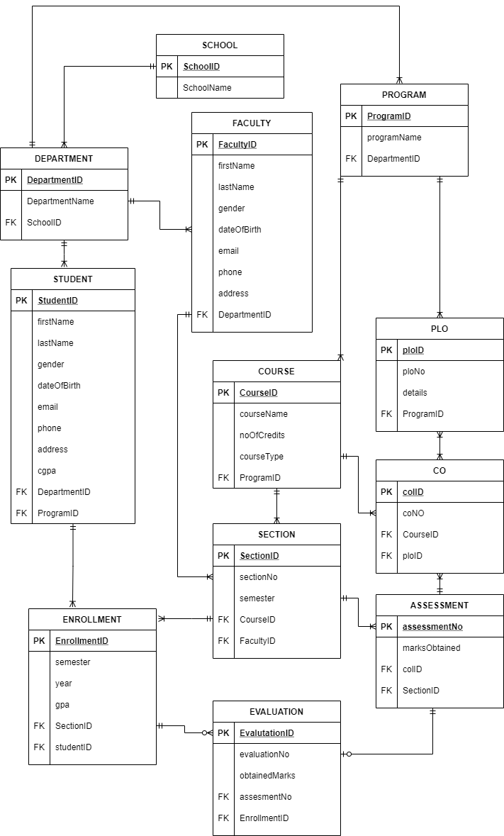**ENTITY RELATIONSHIP DIAGRAM**

**Figure**​ **3.1: Entity Relationship Diagram of SPM**

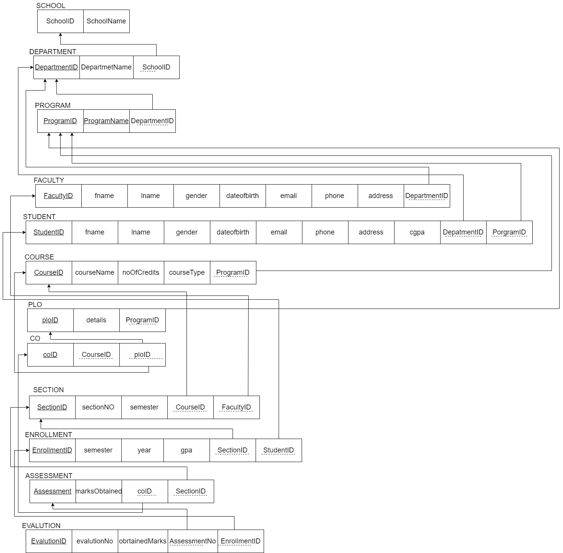**ENTITY RELATIONSHIP DIAGRAM TO RELATIONAL SCHEMA**

**Figure**​ **3.2: Relational Schema Diagram of SPM**

NORMALIZATION

|  |  |  |  |  |  |
| --- | --- | --- | --- | --- | --- |
| School | SchoolID | s1 | Faculty | FacultyID | f1 |
| SchoolName | s2 | fname | f2 |
| Department | DepartmentID | d1 | lname | f3 |
| DepartmentName | d2 | gender | f4 |
| SchoolID | s1 | dateOfBirth | f5 |
| Program | ProgramID | r1 | email | f6 |
| ProgramName | r2 | phone | f7 |
| DepartmentID | d1 | address | f8 |
| Student | StudentID | t1 | DepartmentID | d1 |
| fname | t2 | Course | CourseID | o1 |
| lname | t3 | courseName | o2 |
| dateOfBirth | t4 | noOfCredits | o3 |
| gender | t5 | courseType | o4 |
| email | t6 | ProgramID | r1 |
| phone | t7 | PLO | ploID | p1 |
| address | t8 | details | p2 |
| cgpa | t9 | ProgramID | r1 |
| DepartmentID | d1 | Section | SectionID | q1 |
| ProgramID | r1 | sectionNo | q2 |
| CO | coID | c1 | semester | q3 |
| ploID | p1 | CourseID | o1 |
| CourseID | o1 | FacultyID | f1 |
| Enrollment | EnrollmentID | e1 | Evaluation | EvaluationID | v1 |
| semester | e2 | evaluationNo | v2 |
| year | e3 | obtainedMarks | v3 |
| gpa | e4 | assessmentNo | a1 |
| StudentID | t1 | EnrollmentID | e1 |
| SectionID | q1 | Assessment | assessmentNo | a1 |
|  |  | marksObtained | a2 |
|  | | | coID | c1 |
| SectionID | q1 |

|  |  |
| --- | --- |
| s1🡪 | s2 |
| d1🡪 | d2, s1 |
| r1🡪 | r2, d1 |
| f1🡪 | f2, f3, f4, f5, f6, f7, f8, d1 |
| t1🡪 | t2, t3, t4, t5, t6, t7, t8, t9, r1, d1 |
| o1🡪 | o2, o3, o4, r1 |
| p1🡪 | p2, r1 |
| c1🡪 | p1, o1 |
| q1🡪 | q2, q3, o1, f1 |
| e1🡪 | e2, e3, e4, q1, t1 |
| a1🡪 | a2, c1, q1 |
| v1🡪 | v2, v3, a1, e1 |

|  |  |
| --- | --- |
| SchoolID**➔** | SchoolName |
| DepartmentID**➔** | DepartmentName, SchoolID |
| ProgramID**➔** | programName, DepartmentID |
| FacultyID**➔** | fname, lname, gender, dateOfBirth, email, phone, address, DepartmentID |
| StudentID**➔** | fname, lname, dateOfBirth, gender, email, phone, address, cgpa, DepartmentID, ProgramID |
| CourseID**➔** | courseName, noOfCredits, courseType, ProgramID |
| ploID**➔** | details, ProgramID |
| coID**➔** | ploID, CourseID |
| SectionID**➔** | sectionNo, semester, CourseID, FacultyID |
| EnrollmentID**➔** | semester, year, gpa, SectionID, StudentID |
| assessmentNo**➔** | marksObtained, ocID, SectionID |
| EvaluationID**➔** | evaluationNo, obtainedMarks, assesmentNo, EnrollmentID |





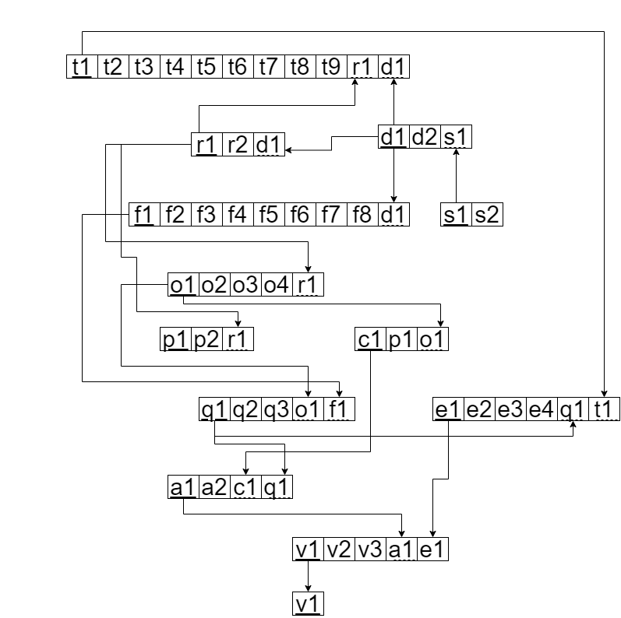

**DATA DICTIONARY**

**School_T**

|  |  |  |  |
| --- | --- | --- | --- |
| **Name** | **Data Type** | **Size** | **Remark** |
| cschoolID | VARCHAR22 | 5 | This is the Primary Key of School Example: “SETS” |
| cschoolName | VARCHAR22 | 50 | This is the name of the School. Example: “School of Engineering, Technology and Science” |

**Department_T**

|  |  |  |  |
| --- | --- | --- | --- |
| **Name** | **Data Type** | **Size** | **Remark** |
| cdepartmentID | VARCHAR22 | 5 | This is the Primary Key of the Department. Example: “CSE” |
| cdepartmentName | VARCHAR22 | 50 | This is the name of the Department. Example: “Computer Science and Engineering” |
| cschool_id | VARCHAR22 | 5 | This is the Foreign Key of the table School. Example: “SETS” |

**Program_T**

|  |  |  |  |
| --- | --- | --- | --- |
| **Name** | **Data Type** | **Size** | **Remark** |
| cprogramID | VARCHAR22 | 5 | This is the Primary Key for a Program Example:” B.Sc”. |
| cprogramName | VARCHAR22 | 50 | This is the name of the Degree Program. Example: “Bachelor of Science” |
| cdepartment_id | VARCHAR22 | 5 | This is the Foreign Key from the Department table. Example: “CSE |

**Course_T**

|  |  |  |  |
| --- | --- | --- | --- |
| **Name** | **Data Type** | **Size** | **Remark** |
| ccourseID | VARCHAR22 | **7** | This is the Primary Key for the Course. Example: “CSE203” |
| ccourseName | VARCHAR22 | **50** | This is the name of the Course. Example:” Data Structure” |
| nnoOfCredits | INTEGER | **1** | This is the credit for the Course. Example: ”3” |
| ccourseType | VARCHAR2 | **20** | This is the type of the Course. Example: “Core” |
| cprogram_id | VARCHAR2 | **5** | This is the Foreign Key from Program table Example:” B.Sc”. |

**Faculty_T**

|  |  |  |  |
| --- | --- | --- | --- |
| **Name** | **Data Type** | **Size** | **Remark** |
| cfacultyID | VARCHAR22 | 4 | This is the Primary Key for Faculty. Example: “1803” |
| cfname | VARCHAR22 | 50 | This is the first name of the Faculty. Example: “​Sadita” |
| clname | VARCHAR22 | 20 | This is the last name of the Faculty Example: “Ahmed” |
| ddateOfBirth | DATE | DD-MM-Y | This the Date of Birth of the Faculty YYY  Example: “01-01-1993” |
| cgender | VARCHAR22 | 1 | This is the gender of the Faculty. Example: “F” |
| cemail | VARCHAR22 | 50 | This is the email address of the Faculty. Example: “sadita@iub.edu.bd” |
| cphone | CHAR | 11 | This is the phone number of the Faculty. Example: “01292383111” |
| caddress | VARCHAR22 | 50 | This is the address of the Faculty. Example: “House 1, Road 1, Sector 1, Area, Dhaka, Bangladesh, |
| cdepartment_id | VARCHAR22 | 5 | This is the Foreign Key from the Department table. Example: “CSE” |

**Student_T**

|  |  |  |  |
| --- | --- | --- | --- |
| **Name** | **Data Type** | **Size** | **Remark** |
| cstudentID | VARCHAR22 | 7 | This is the Primary Key for the Student. Example: “1800001” |
| cfname | VARCHAR22 | 50 | This is the first name of the Student. Example: “Shoban” |
| clname | VARCHAR22 | 50 | This is the last name of the Student. Example: “Bhowmik” |
| ddateOfBirth | DATE | DD-MM- YYYY | This the Date of Birth of the Student. Example: “01-01-1998” |
| cgender | VARCHAR22 | 1 | This is the gender of the Student. Example: “M” |
| cemail | VARCHAR2 |  | This is the email address of the Student. Example: “1850105@iub.edu.bd” |
| cphone | CHAR | 11 | This is the phone number of the Student. Example: “0191211141” |
| caddress | VARCHAR2 | 50 | This is the address of the Student. Example: “House 1, Road 1, Sector 1, Area, Dhaka, Bangladesh” |
| ncgpa | NUMBER | 3,2 | This is the cgpa of the Student. Example: 4.00 |
| cdepartment_id | VARCHAR2 | 50 | This is the Foreign Key from the Department table. Example: “CSE” |
| cprogram_id | VARCHAR2 | 50 | This is the Foreign Key from Program table Example:” B.Sc”. |

**Section_T**

|  |  |  |  |
| --- | --- | --- | --- |
| **Name** | **Data Type** | **Size** | **Remark** |
| nsection_id | INTEGER |  | This is the Primary Key for Section |
| nsectionNo | INTEGER |  | This is the section number. Example: “1” |
| ccourse_id | VARCHAR2 | 7 | This is the foreign key from the Course table. Example: “CSE101” |
| cfaculty_id | VARCHAR2 | 4 | This is the foreign key from Faculty table Example: “CO1” |

**Evaluation_T**

|  |  |  |  |
| --- | --- | --- | --- |
| **Name** | **Data Type** | **Size** | **Remark** |
| nevaluationID | INTEGER |  | This is the Primary Key for Evaluation |
| nobtainedMarks | NUMBER | 5,2 | This is the marks obtained by the Student Example: “29.5” |
| nassessment_id | INTEGER |  | This is the Foreign Key from Assessment table |

**Enrollment_T**

|  |  |  |  |
| --- | --- | --- | --- |
| **Name** | **Data Type** | **Size** | **Remark** |
| nenrollmentID | INTEGER |  | This is the Primary Key for Enrollment |
| csemester | VARCHAR2 | 6 | This is the semester of Enrollment Example: “Summer” |
| dyear | YEAR | YYYY | This is the year of Enrollment. Example: “2018” |
| ngpa | NUMBER | 3,2 | This is the gpa of the semester. Example: 4.00 |
| nsection_id | INTEGER |  | This is the Foreign Key from Section table |
| cstudent_id | VARCHAR2 | 7 | This is the Foreign key from the Student Table. Example: “1800001” |

**Assessment_T**

|  |  |  |  |
| --- | --- | --- | --- |
| **Name** | **Data Type** | **Size** | **Remark** |
| nassessmentID | INTEGER |  | This is the Primary Key for Enrollment |
| cmarks | VARCHAR2 | 6 | This is the semester of Enrollment Example: “Summer” |
| nsection_id | INTEGER |  | This is the Foreign Key from Section table |
| ncourse_id | INTEGER |  | This is the Foreign Key from the Course Outcome table Example: |

PLO_T

|  |  |  |  |
| --- | --- | --- | --- |
| **Name** | **Data Type** | **Size** | **Remark** |
| cplo_id | VARCHAR22 | 5 | This is the primary key for Program Learning Outcome. Example: “PLO1” |
| cdetails | VARCHAR22 | 50 | This is the details of the Program Learning Outcome. Example: “An ability to select and apply the knowledge, techniques, skills, and modern |
| cprogram_id | VARCHAR22 | 5 | This is the foreign key from Program table Example: ”B.Sc”. |

**CO_T**

|  |  |  |  |
| --- | --- | --- | --- |
| **Name** | **Data Type** | **Size** | **Remark** |
| nco_id | INTEGER | 2 | This is the number of the Course Outcome. Example: ”1” |
| ccourse_id | VARCHAR22 | 7 | This is the Foreign Key from the Course table. Example: “CSE101” |
| cplo_id | VARCHAR22 | 5 | This is the foreign key from the Program Learning Outcome table. Example: “PLO1” |